**Project Design Phase-II Technology Stack (Architecture & Stack)**

|  |  |
| --- | --- |
| Date | 31 October 2022 |
| Team ID | PNT2022TMID50617 |
| Project Name | SMART FARMER - IOT ENABLED SMART FARMING APPLICATION SYSTEM |
| Maximum Marks | 4 Marks |

**Technical Architecture:**

The Deliverable shall include the architectural diagram as below and the information as per the table1 & table 2

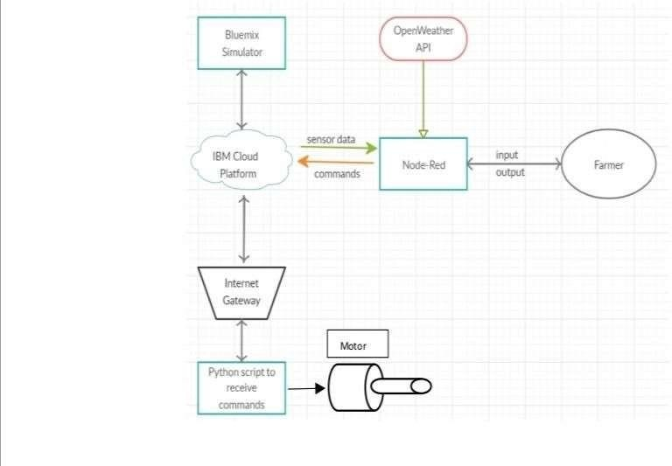

Guidelines:

1. Include all the processes (As an application logic / Technology Block)
2. Provide infrastructural demarcation (Local / Cloud)
3. Indicate external interfaces (third party API’s etc.)
4. Indicate Data Storage components / services
5. Indicate interface to machine learning models (if applicable)

**Table - 1: Components & Technologies:**

|  |  |  |  |
| --- | --- | --- | --- |
| **SI. No** | **Component** | **Description** | **Technology** |
| 1. | User Interface | How user interacts with application e.g. WebUI, Mobile App. | HTML, CSS, JavaScript / Angular Js / React Js etc. |
| 2. | Application Logic-1 | Logic for a process in the application | Python |
| 3. | Application Logic-2 | Logic for a process in the application | IBM Watson IOT service |
| 4. | Application Logic-3 | Logic for a process in the application | IBM Watson Assistant |
| 5. | Database | Data Type, Configurations etc. | My SQL, No SQL, etc. |
| 6. | Cloud Database | Database Service on Cloud | IBM Cloud |
| 7. | File Storage | File storage requirements | IBM Block Storage or Other Storage Service or Local File system |
| 8. | External API-1 | Purpose of External API used in the application | IBM Weather API, etc. |
| 9. | Machine Learning Model | Purpose of Machine Learning Model | Object Recognition Model, etc. |
| 10. | Infrastructure (Server / Cloud) | Application Deployment on Local System / Cloud Local Server Configuration:  Cloud Server Configuration: | Local, Cloud Foundry, Kubernetes, etc. |

**Table-2: Application Characteristics:**

|  |  |  |  |
| --- | --- | --- | --- |
| **S. No** | **Characteristics** | **Description** | **Technology** |
| 1. | Open-Source Frameworks | List the open-source frameworks used | Technology of Open source framework |
| 2. | Security Implementations | Sensitive and private data must be protected from their production until the decision-making and storage  stages. | e.g. Node-Red, Open weather App API,MIT App Inventor, etc. |
| 3. | Scalable Architecture | scalability is a major concern for IoT platforms. It has been shown that different architectural choices of IoT platforms affect system scalability and that automatic real time decision-making is feasible in an  environment composed of dozens of thousand. | Technology used |
| 4. | Availability | Automatic adjustment of farming equipment made possible by linking information like crops/weather and equipment to auto-adjust temperature, humidity, etc. | Technology used |
| 5. | Performance | The idea of implementing integrated sensors with sensing soil and environmental or ambient parameters  in farming will be more efficient for overall monitoring. | Technology used |